Developing Android Companion Application to Collect Data from PineTime64 smart watch

Heterogeneous Computing (COE 504)

Submitted by

MD Siddiqur Rahman Tanveer (PhD Student, CoE, 202417180)

F M Jahiduzzaman (Masters Student, CoE, 202417000)

Department of Computer Engineering

King Fahd University of Petroleum and Minerals (KFUPM)

**Bluetooth Low Energy**

Android provides built-in platform support for Bluetooth Low Energy (BLE) in the central role and provides APIs that apps can use to discover devices, query for services, and transmit information.

Common use cases include the following:

* Transferring small amounts of data between nearby devices.
* Interacting with proximity sensors to give users a customized experience based on their current location.

In contrast to [classic Bluetooth](https://developer.android.com/develop/connectivity/bluetooth), BLE is designed for significantly lower power consumption. This allows apps to communicate with BLE devices that have stricter power requirements, such as proximity sensors, heart rate monitors, and fitness devices.

**The basics**

For BLE-enabled devices to transmit data between each other, they must first form a channel of communication. Use of the Bluetooth LE APIs requires you to [declare several permissions](https://developer.android.com/develop/connectivity/bluetooth/bt-permissions) in your manifest file. Once your app has permission to use Bluetooth, your app needs to access the BluetoothAdapter and [determine if Bluetooth is available on the device](https://developer.android.com/develop/connectivity/bluetooth/setup) If Bluetooth is available, the device will [scan for nearby BLE devices](https://developer.android.com/develop/connectivity/bluetooth/ble/find-ble-devices). Once a device is found, the capabilities of the BLE device are discovered by [connecting to the GATT server on the BLE device](https://developer.android.com/develop/connectivity/bluetooth/ble/connect-gatt-server). Once a connection is made, [data can be transferred with the connected device](https://developer.android.com/develop/connectivity/bluetooth/ble/transfer-ble-data) based on the available services and characteristics.

**Key terms and concepts**

The following is a summary of key BLE terms and concepts:

* **Generic Attribute Profile (GATT)**

The GATT profile is a general specification for sending and receiving short pieces of data known as "attributes" over a BLE link. All current BLE application profiles are based on GATT. Review the [Android BluetoothLeGatt sample](https://github.com/android/platform-samples/tree/main/samples/connectivity/bluetooth/ble/src/main/java/com/example/platform/connectivity/bluetooth/ble) on GitHub to learn more.

* **Attribute Protocol (ATT)**

GATT is built on top of the Attribute Protocol (ATT). This is also referred to as GATT/ATT. ATT is optimized to run on BLE devices. To this end, it uses as few bytes as possible. Each attribute is uniquely identified by a Universally Unique Identifier (UUID), which is a standardized 128-bit format for a string ID used to uniquely identify information. The *attributes* transported by ATT are formatted as *characteristics* and *services*.

**Android BluetoothLeGatt Sample**

This sample demonstrates how to use the Bluetooth LE Generic Attribute Profile (GATT) to transmit arbitrary data between devices.

**Introduction**

This sample shows a list of available Bluetooth LE devices and provides an interface to connect, display data and display GATT services and characteristics supported by the devices.

It creates a [Service](http://developer.android.com/reference/android/app/Service.html) for managing connection and data communication with a GATT server hosted on a given Bluetooth LE device.

The Activities communicate with the Service, which in turn interacts with the [Bluetooth LE API](https://developer.android.com/reference/android/bluetooth/BluetoothGatt.html).

**Pre-requisites**

* Android SDK 28
* Android Build Tools v28.0.3
* Android Support Repository

**Screenshots**

[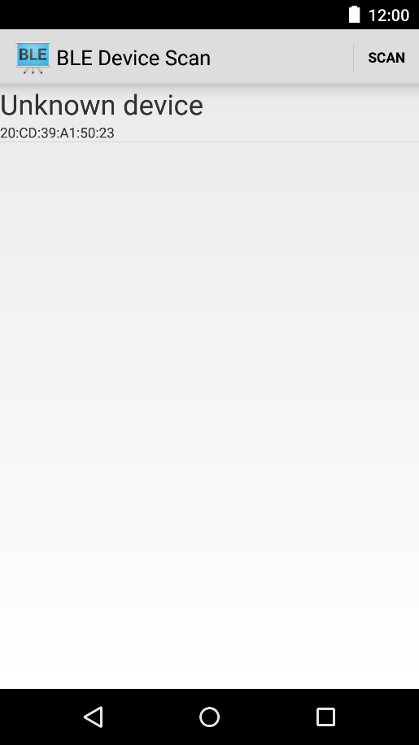](https://github.com/android/connectivity-samples/blob/master/BluetoothLeGatt/screenshots/1-main.png) [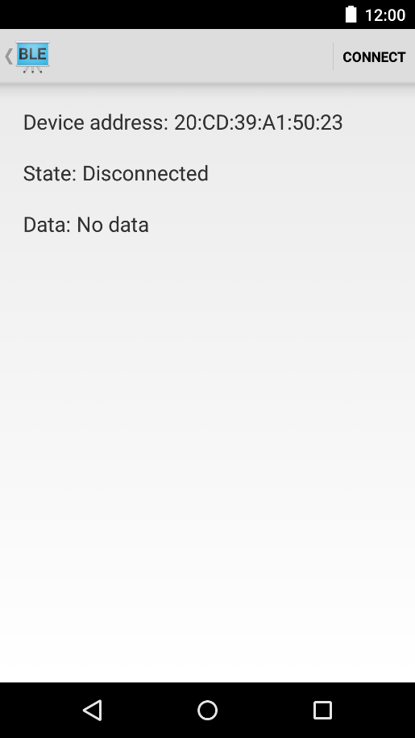](https://github.com/android/connectivity-samples/blob/master/BluetoothLeGatt/screenshots/2-detail.png)

**How does Android Application Connect to GATT Server?**

